LAB LOG BOOK
WEEK 6
Ipolt was given me an error so I decided to use only plotly (see error below)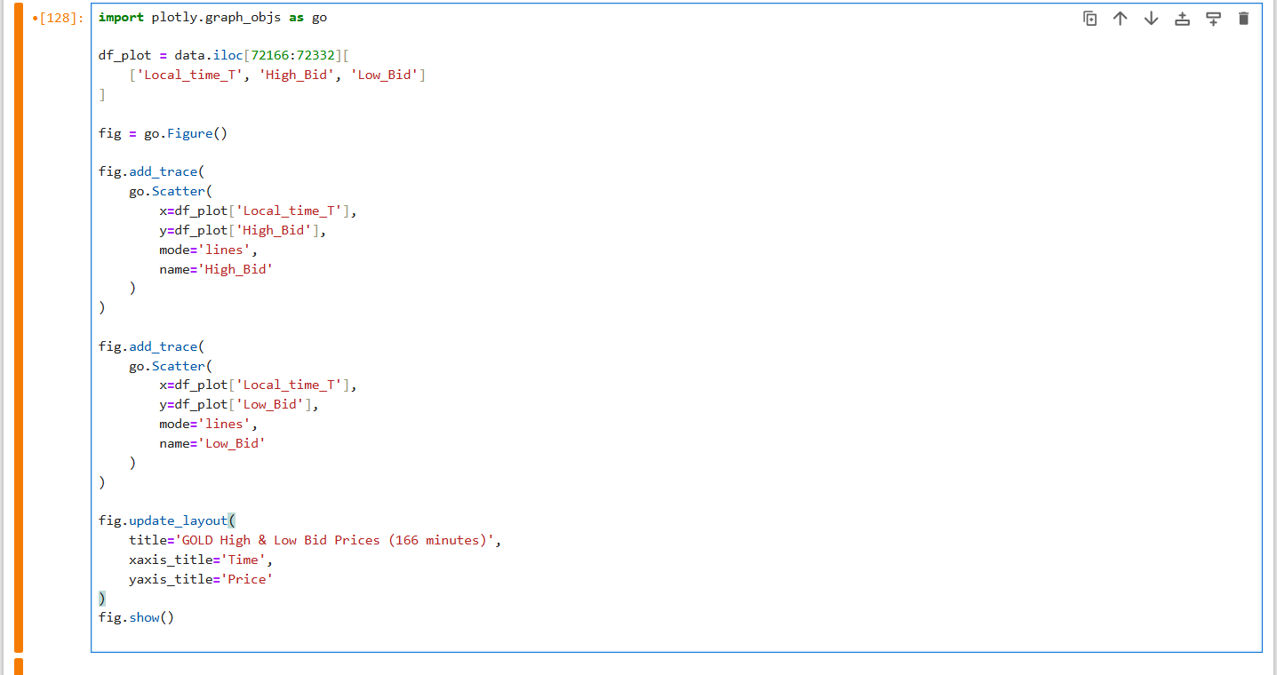

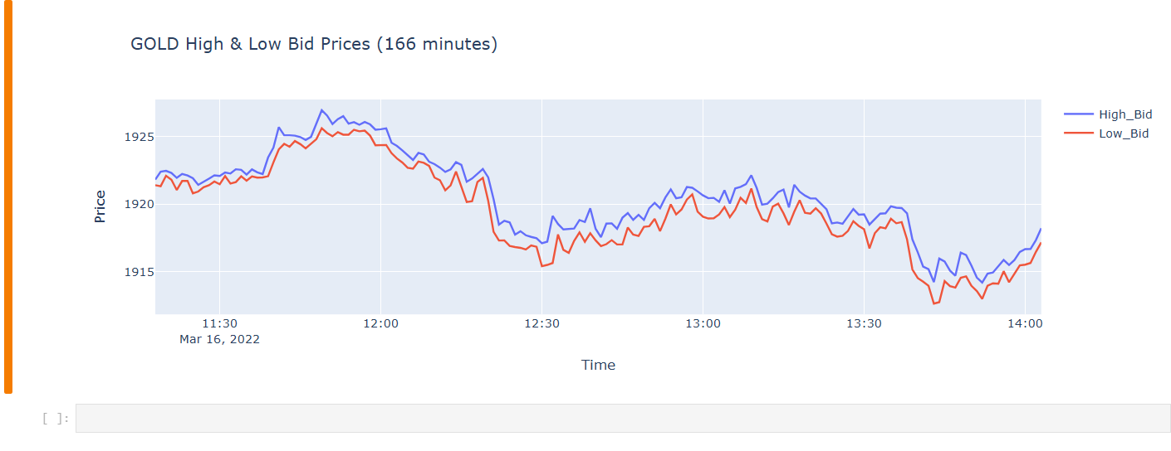

Error
